

[Twitter Checklist](https://swgfl.org.uk/resources/checklists/twitter/)



[Instagram Checklist](https://swgfl.org.uk/resources/checklists/instagram/)

[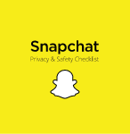](https://swgfl.org.uk/resources/checklists/snapchat/)

[Snapchat Checklist](https://swgfl.org.uk/resources/checklists/snapchat/)

[](https://swgfl.org.uk/resources/checklists/roblox/)

[Roblox Checklist](https://swgfl.org.uk/resources/checklists/roblox/)



[TikTok Checklist](https://swgfl.org.uk/resources/checklists/tiktok/)

[](https://swgfl.org.uk/resources/checklists/netflix-checklist/)

[Netflix Checklist](https://swgfl.org.uk/resources/checklists/netflix-checklist/)