Finding your operating system

Version 1.0

Contents

How to check your Apple iPad iOS version 3
How to check your Android version 4
How to check your Windows Software version 5

How to check your Apple iPad iOS version

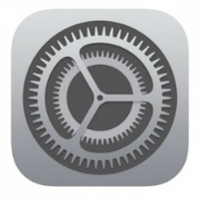
- On the main screen look for the settings icon.

If necessary, you may have to swipe left/right to additional screens.

- Tap on the ‘Settings’ icon
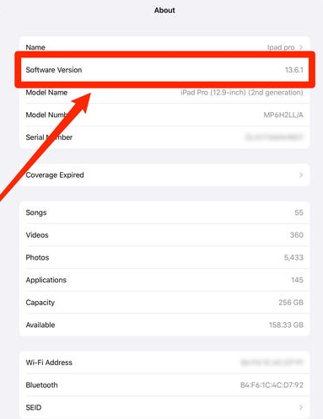
- Navigate down to General > About
You will see your software version here e.g. 13.6.1

Cyber Essentials requires you to be running the most up to date operating system.

- Check to see if you can update your iPad to a later version:

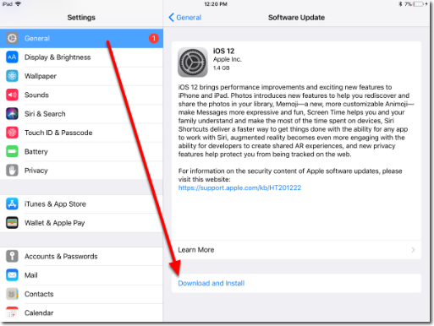
- Settings > General > Software Update

- Download and install an update if it is available

Please note that installing an update requires the device to be plugged in and charging, and it will take some time – you might want to do this after hours.
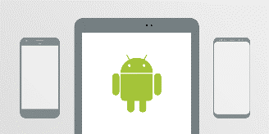

How to check your Android version

- On the Home screen of your phone or tablet, swipe up to access your apps screen

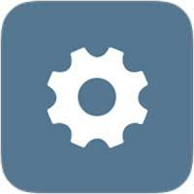
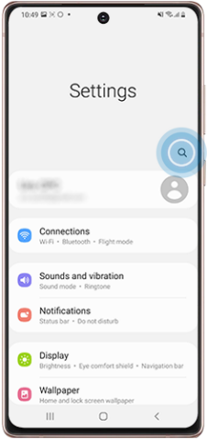
- Tap on the ‘Settings’ icon
3

- Tap on the ‘search’ icon
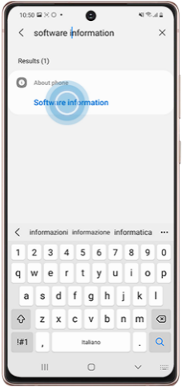
and type ‘software information’
4

- Tap on ‘software information’ to open up the details

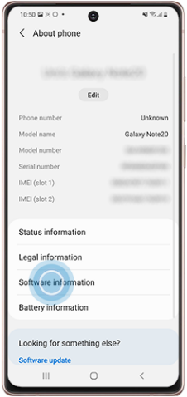
- Again, tap on ‘software information’
5

- The Android version that your device is
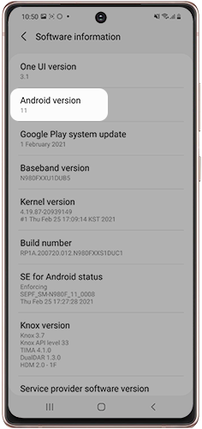
running will be displayed
6
To check you have the latest Android software:
- From Home screen swipe up
- Tap on ‘Settings’
- Scroll down to, and then tap ‘software update’
Here you can see when your device was last updated.
- Tap ‘download and install’ to check for system updates
(you may need to tap ‘Download Now’ – models vary)

How to check your Windows Software version

- On the main screen look for the Windows icon located in the bottom left corner.

- Click into the search box

The search bar may be located immediately to the right of the icon.

OR
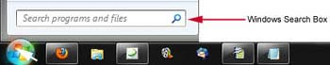
Click the start icon and the search box will appear above it.

- In the search box, type ‘version’ and press ENTER.

This is your Operating System version (OS name):

