 | Internet Matters  Age specific online safety checklists, practical tips and informative guides. | Early years online safety resources  Online safety resources for primary schools  Secondary schools online safety resources
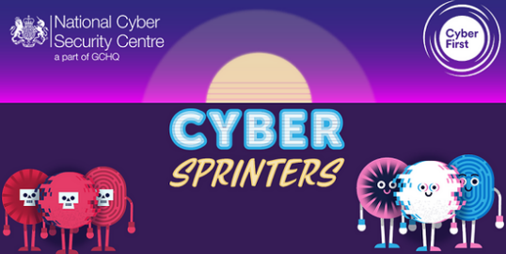 | National Cyber Security Centre  A government organisation providing advice and support in how to avoid computer security threats. | CyberSprinters: Game and activities  Cyber Security for Schools
 | Childnet International  A non-profit organisation helping to make the internet a great and safe place for children. | Primary  Secondary  Teacher & Professionals
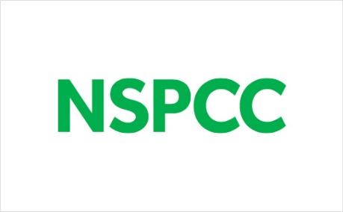 | NSPCC  Support and tips to help you keep children safe. From advice on children’s mental health to staying safe online, support for parents and what to do if you’re worried about a child. | Online Safety for Children - Tips & Guides  Online safety resources for schools and organisations
 | UK Safer Internet Centre  Online safety tips, advice and resources to help children and young people online. | Young people  Resources for 3-11s  Resources for 11-19s  Parents and Carers  Teachers and school staff
 | ThinkUKnow  An education programme from the Child Protection Command of the National Crime Agency. | 4-7s Homepage  Thinkuknow 8-10s  Thinkuknow 11-13s  Thinkuknow 14+
 | London Grid for Learning  A not-for-profit trust passionate about keeping children safe online. | Online Safety Resource Centre
 | South West Grid for Learning  A charity dedicated to empowering the safe and secure use of technology. | Back to School Pack!  Swiggle.org.uk - Child Friendly Search Engine  Whisper® - Anonymous Reporting Tool for your School Community
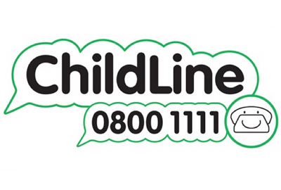 | Childline  A counselling service for children and young people up to 19yrs. | Staying safe online  Online and mobile safety  Remove a nude image shared online
 | BBC Teach  Free primary and secondary teaching resources. | Online safety - BBC Teach
 | Child Exploitation and Online Protection Command  A law enforcement agency and is here to help keep children and young people safe from sexual abuse and grooming online. | CEOP - YouTube
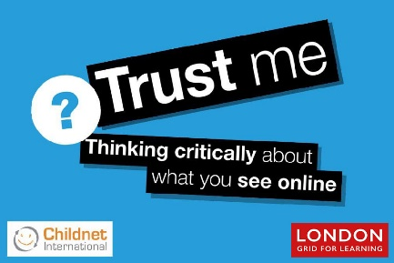 | Trust me  A site developed to encourage young people to think critically when faced with information online, with downloadable resource packs. | Trust Me - London Grid for Learning
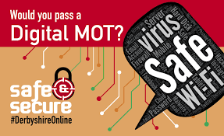 | Safer Derbyshire  A website for community safety. | Welcome to your Digital MOT
 | i-vengers  Engaging and education young explorers of digital technology. | Workshops – i-vengers
 | Childnet Digital Leaders Programme  A youth leadership training programme empowering young people to educate their peers about online safety. | Resources - Childnet
 | Safer Internet Day  Website dedicated to the annual ‘Safer Internet Day’ every February. | Resources - Safer Internet Day
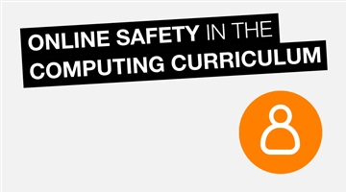 | Online Safety in the Computing Curriculum  Embedding online safety teaching across the curriculum is considered effective practice. | KS1 - Childnet  KS2 - Childnet  KS3 - Childnet  KS4 - Childnet
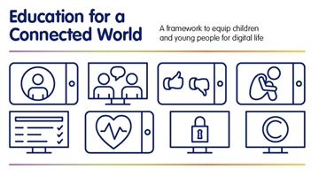 | Education for a Connected World  Government document describing the digital knowledge and skills that children and young people should have the opportunity to develop. | Education for a Connected World
 | Net Aware  A collaboration, using NSPCC’s knowledge and O2’s technical know-how to keep children safe online. | Online safety resources  Apps, games and social media sites reviews for parents  Top tips
 | Ask about games  Specific advice and guides about online gaming, supporting users to understand content. | Video Game Guides  All About: PEGI Age Ratings  All About: Family Settings
 | Report Harmful Content  Empowering anyone who has come across harmful content online to report it. | Submit a Report of Harmful Content  Advice - Report Harmful Content

